“连易通”和“苏康码”申领地址

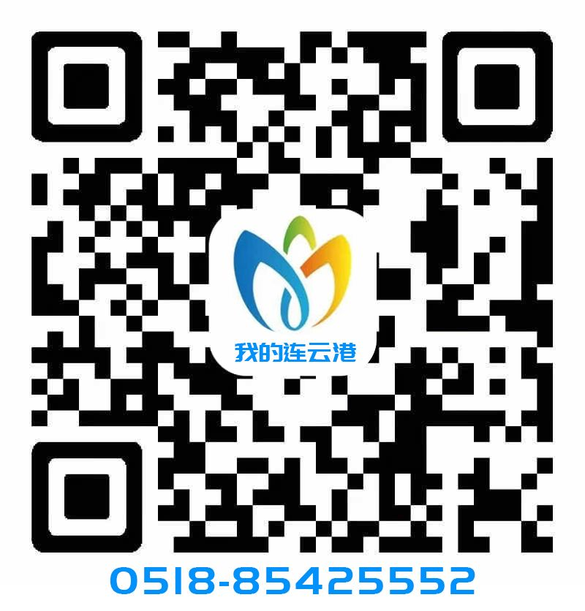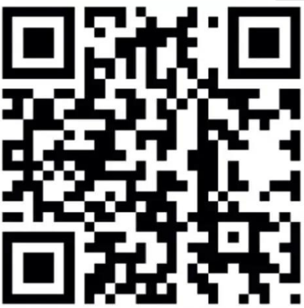
“连易通” “苏康码”

